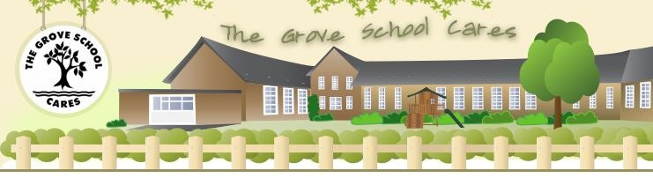


The

Grove

Primary

School

"The

Grove

School

Cares"

Behaviour Policy
March 2026

Ms

Bernadette Atkinson

Head

Teacher

Oakfield

Lane,

The

Grove,

Consett,

Co.

Durham,

DH8

8
AP

Tel

01207

502938

Email:

enquiries@thegroveprimaryschool.co.uk earning.net

Document Control
Document reference: | Behaviour policy | Date implemented: | 1/9/2020
Version: | 19.4 | Date modified:
Revision due date: |  | Publication: | External
Reviewed by: | Carly Grundy | Sign and date: | 1st March 2026
Authorised by: | Governing Body | Sign and date: | 19th March 2026

Change History
Version | Date | Description
18.1 | 21/05/2021 | Updated policy based on child and staff feedback.
19.0 | 05/03/2022 | Updated policy based on child and staff feedback.
19.1 | 01/06/2024 | Update on colour ladder based on child feedback
19.2 | 01/09/2024 | Reviewed policy
19.3 | 01/03/2026 | Reviewed policy with staff.  Adding low level system  Reviewed ladder criteria

Related Documents/Policies
References | Title
 | Play Policy

Contents page

- Introduction
- Aims
- Curriculum and Classroom Management
- Staff Responsibilities
- Recognition
- House point system
- Consequences
- Behaviour ladder
- Special educational needs and disabilities (SEND)
- Playtimes and Lunchtimes
- Restorative approach
- Fixed term and Permanent exclusions
- Recording, monitoring and evaluating behaviour
- Pastoral Support
- Physical restraint
- Sexual harassment
- Monitor and review
Appendix 1: Restorative Justice Approach Behaviour Form

- Introduction

Our school motto is: “We care, we share, we play, we learn” We hope that our behaviour policy will help children to thrive at our school.

At The Grove Primary School, we aim to use a positive approach to discipline which is fair and consistent, and which establishes a safe, orderly, positive environment in which both children and staff may flourish.
There is always a choice about “What am I going to do?” Everyone is responsible for the choices they make…

We are a Rights Respecting School

As a bronze level Rights Respecting school, we are committed to learning about and promoting children’s right and have therefore used the UNCRC articles to inform this policy.
Article 28 and 29 state that: Every child has the right to a good quality education. Education must develop every child’s personality, talents and abilities to the full. It must encourage the child’s respect other people, their own and other cultures, and the environment.

- Aims
What we want for our children at The Grove Primary School:
- To have respect for adults and peers.
- To learn in a safe, nurturing and caring environment.
- To be resilient and to be able to use this in and outside the classroom.
- To further promote self-esteem through success, positive relationships and awareness of how our behaviour impacts on ourselves and others
- To help pupils develop self-respect, self-control and accountability for their own behaviour

We are a caring, inclusive school and aim for every member of our school community to feel valued and respected. We all have the right to be treated well and fairly. The school behaviour policy is therefore designed to encourage all stakeholders to work collaboratively and apply the same approaches across all settings in school. It aims to promote an environment where everyone feels safe and secure and where the health and well-being of individuals is paramount. Relationships should be based on fairness, honesty, courtesy and consideration.

Staff are trained in using the Restorative Approach to deal positively and calmly with behaviour issues in school. This approach brings those harmed by conflict and those responsible for the harm into communication with each other to support repairing the harm and work together to find a positive way forward by working together and listening to each other.

Our Behaviour Policy focuses on positive behaviour management, PSHE and is supported in the following ways:
- A carefully planned curriculum
- Effective classroom management
- Adult role-modelling
- Whole school behaviour management plan
- Playtime and lunchtime provision (OPAL)
- Personalised programmes/support from outside agencies for those who need it
- Ensuring that connections between pupils and staff are fostered positively
- Explicit teaching of behaviour

Our positive approach has three main parts:
High Expectations
All staff will have high expectations of our children. We expect that children will also have high expectations of themselves and others. If we aim high, we will all do well together.
Praise and Rewards
All staff will praise and reward children who are meeting our high expectations. Children will receive special rewards such as: money for their chart, stickers, certificates, phone calls home. Staff love to give praise and this can be given to all children showing good manners, hard work, effort and resilience.
Consequences
All staff will ask you to face a consequence if your behaviour is not what we expect. This could be losing money from your chart or missing parts of your playtime. Sometimes we might even ring an adult at home.

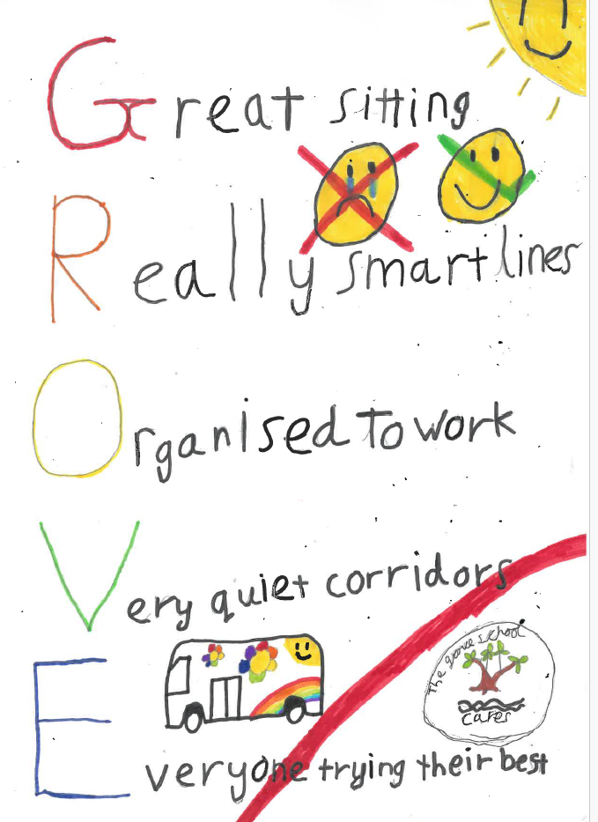
- Curriculum and class management.
Alongside positive relationships, we are aware that good classroom organisation and effective teaching methods are key to good behaviour and that the provision of a high-quality curriculum through interesting and challenging activities influences behaviour.
A welcoming and secure classroom environment gives clear messages to the children about the extent to which they and their efforts are valued. Environments will be organised to promote and develop independence and individual initiative and resilience, whilst minimising disruption and uncertainty.

See Appendix 3

We use explicit teaching of behaviour. This means we will set expectations with the children, so they know what is expected of them. We use the poster above and sometimes verbal instruction. This could be, for example, in assembly explicit instruction before it starts to say that we do great sitting and listening while in the hall. This will help children to know what is expected and teach children how to follow the behaviour expectations.
- Staff Responsibilities

All staff will follow the behaviour policy at The Grove Primary School. This will keep our systems consistent so each child understands what is expected from them by every adult in the building.
Staff will:
- Establish a collaborative ‘Class Charter’ at the beginning of the school year
- To be a role model for good behaviour and positive relationships both online and offline
- To create a positive climate with realistic but high expectations
- To have the behaviour ladder and GROVE poster displayed in the classroom and refer to it as part of their quality first teaching through explicit instruction,
- Have a class money chart for children to earn rewards for following the expectations generated with the class to help motivate children
- To emphasise the importance of values and being valued
- To provide an effective learning and teaching environment
- Staff will frequently go through the behaviour ladder with their class (especially after a weekend or holiday) to remind children about our high expectations
- To encourage positive relationships based on kindness, empathy and respect
- To ensure fair treatment for all regardless of ability, age, sex, race or preconceptions
- Show appreciation of the efforts and contributions of everyone
- Staff will walk with children up and down the corridors and take and collect them from break times
- Staff will actively encourage children to use the toilet during unstructured times to avoid any loss of learning time
- Ensure that article 28 is adhered to at all times: “I have the right to an Education,”

All teachers, support staff and lunchtime supervisors are responsible for the modelling of good behaviour, respect, positive relationships and dealing with incidents around school.
- Recognition

All children in school will be recognised for following the school’s behaviour policy. In school, we will reward children in a number of ways. All adults in school will be able to reward and recognise children’s efforts.

Children will:
- Be rewarded with positive praise from adults and peers
- Receive stickers for good work
- Have a class money bank where they can earn money towards things they like to do.
- Receive certificates from staff for exceptional work/ effort/ resilience
- Earn rewards such as additional playtimes/ non-uniform days/ free choice time.

- House system

In school, children are sorted into four teams on entry to school: Red team, Blue team, Green team and Yellow team. This is to help children have a sense of belonging and feel connected to other classes in the school. The house system can be used for sorting children into groups for PE and for community events like sports day.

- Consequences

We would hope that all children will follow our high standards and expectations in order to learn in a safe environment. For those few who choose not to follow this, we have set consequences. These consequences will be immediate and swift to ensure no learning time is lost.

Staff will:
- Explain to child what they should be doing,
- Remind children in lessons of high expectations we follow,
- Give children one verbal warning so they can swiftly correct their behaviour,
- Remove some money from the money chart if a first warning is not listened to,
- Remove some time from playtime if children are not playing well together,
- Phone call to parents/carers if behaviour continues to not improve,
- Take further action is behaviour is consistently not improving.
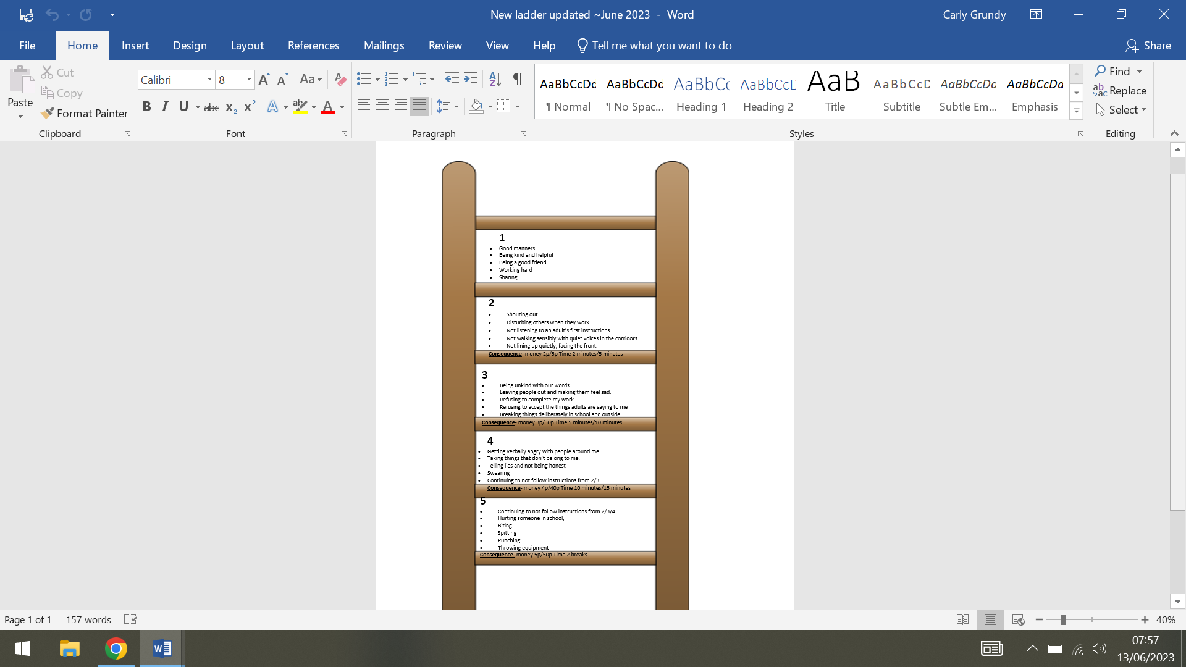
- Behaviour ladder

In school each adult will use the 5-point behaviour ladder. This is designed to create a consistent approach to behaviour across the school for all adults and children. Staff will display the behaviour ladder in the classroom with names or photos of children.

Children will only need to be placed on the ladder if they reach step 2-5. It is expected that at all times children will be at step 1 as this is expected behaviour.

Children will be placed on the ladder to visually remind them that they have not followed a high expectation within school. Children can ‘earn’ their way back to green on the ladder by correcting their behaviour or taking a consequence. This is our restorative approach.

Children might do this by:
- Working hard in the lesson
- Showing good manners
- Being kind and helpful
- Being a good friend
- Sharing

These are our expected behaviours at school. Staff will help children to notice these when they are trying to restore their behaviours “ X I can see you are sitting so smartly with you hand up… move yourself back to green for good manners.”

How it works

The ladder should offer flexibility and restoration and children may move up and down the ladder based on their responses to adult prompts.

Example: A child might be refusing to complete their work. They receive one verbal warning to start. This is a level 3 on the scale. The child’s name or photo will be placed on the 3. The adult will then look at the consequences for this stage and decide what is the most appropriate as they know the child the best this will be most likely, missing playtime or removing money.

This should be done swiftly without interfering with the learning in the lesson for the child or others. Once the child has taken the consequence and begins to show the high expectations, we are looking for they move straight off the ladder. Staff will actively look for behaviours from the green to move children back up.

Adults might read out the expectations of level 1 to remind children (especially SEND) of how to get off the ladder again and what behaviours to show i.e. “ If you do three more questions you will move to 2,”

If children persist with poor choices, they might move to a level 4 or 5 and this would then demand more consequences for the child until they can make those good choices again. They would be given no more verbal chances and would continue to lose money or time.

Scale | Behaviours seen | How it will make others feel | Consequences
1 | - Good manners  - Being kind and helpful  - Being a good friend  - Working hard  - Sharing | - My teachers will be happy and proud  - My grown ups at home will be proud and happy  - My friends will enjoy spending time with me. | - Will receive all your playtimes and lunchtimes.  - Will receive money for your chart.  - You can use this money to buy things you like to do i.e. a non-uniform day.
One verbal chance given to a child or class
2 | - Shouting out  - Disturbing others when they work  - Not listening to an adult’s first instructions  - Not walking sensibly with quiet voices in the corridors  - Not lining up quietly, facing the front. | - My teachers will be worried I am stopping other people from learning or playing.  - My grownups at home will be sad that I am affecting the learning and play of other children | - You will have money removed from your chart (2p KS1 or 20p KS2) or:  - You will lose 2/5 minutes off your playtime to stand with an adult or against the white wall.  - You will be reminded of green expectations.
3 | - Being unkind with our words.  - Leaving people out and making them feel sad.  - Refusing to accept the things adults are saying to me  - Breaking things deliberately in school and outside.  - Being disrespectful with my words or actions  - Being inappropriate with my behaviour or making someone feel uncomfortable. | - The adults in school will feel sad and might decide I have to miss out on something.  - If I break something on purpose I might have to pay for it. | - You will have money removed from your chart ( 3p EY/ KS1, 30p KS2) or:  - You will lose 5/ 10 mins of your playtime to stand with an adult or against the white wall.  - You will be reminded of green expectations
4 | - Refusing to complete my work.  - Getting verbally angry with people around me.  - Taking things that don’t belong to me.  - Telling lies and not being honest  - Swearing  - Continuing to not follow instructions from 2/3 | - My friends might not want to play with me. They might feel scared.  - People might not want to share with me in case I take it.  - Adults will be worried I can’t keep myself safe and might have to stop me from doing something. | - You will have more money removed from your chart ( 4p EY/ KS1, 40p KS2) AND  - You will lose 10/ 15 mins of your playtime to stand with an adult or against the white wall  - You will have to explain your behaviour and why you have acted the way you have. This will be in your own time to not miss lesson time.  - You will be reminded of green expectations
5 | - Continuing to not follow instructions from 2/3/4  - Hurting someone in school,  - Biting  - Spitting  - Punching  - Throwing equipment | - Someone could be hurt they might have to go home to feel better.  - Adults will be very cross that you have hurt someone in the school they care about.  - Adults might feel so cross that they have to stop you from doing it again.  - Grownups will feel very sad that you have done something in school. They might not let you do something you like at home. | - You will have more money removed from your chart (5p EY/ KS1, 50p KS2) AND  - You will lose ALL of your two NEXT playtimes to stand with an adult or against the white wall  - You will not be allowed to stay with your friends  - Contact made about your behaviour to your grownups.  - You might have to write/ say sorry to the person you have hurt to make them feel better.  - You might miss out on doing something fun with your whole class. i.e. whole class treats

The Grove Primary School: 5 point scale for behaviour
The ladder is split into a 5-point scale. 1 being the expected behaviour and 5 being the most severe behaviour. Children will enter the ladder based on their behaviour from the following chart. *If you do not have enough money to remove you will lose double the amount of playtime i.e. on 4 on the ladder you would then lose 20/30 minutes. KS1
- Systems for low level behaviour concerns

Low Level behaviour can take 30 minutes of learning away each day (DFE National Behaviour survey https://www.gov.uk/government/publications/national-behaviour-survey-report-2024-to-2025-academic-year )

As a result of this, we want to tackle it to ensure no time is lost to children making poor choices.

For the purpose of this document, we are classing low level as: disrupting in class, not listening, calling out, not getting on with work/ being ready to work, being disrespectful to staff.

Child A: OFTEN
Time: if a few weeks of ladder 2/3 start a behaviour intervention.
On the ladder often but only getting to 2/3.
Consider what behaviour is causing them to go on the ladder at this level? | Classroom staff
Consider what reasonable adjustment could be made i.e. sticker chart or countoons to work on ONE behaviour. | Classroom staff
If there is an improvement maintain for a period of time before removing the adjustment. | Classroom staff
If no improvement meet with parents/carers to discuss the next stage. Which would be one/ two weeks after poor behaviour. | Classroom staff

Child B: DAILY
Time: if a few weeks of ladder 2/3 start a behaviour intervention.
On the ladder daily.
Consider what behaviour is causing them to go on the ladder at this level? | Classroom staff
Make parents aware of behaviour i.e. phone call or catch at home time. This will support with any further action that might be needed. | Classroom staff
Consider what reasonable adjustment could be made i.e. sticker chart or countoons to work on ONE behaviour. | Classroom staff
If there is an improvement maintain for a period of time before removing the adjustment. | Classroom staff
If no improvement meet with parents/carers to look at next stage. Which would be after one week. | Classroom staff

We would hope that this would be sufficient to improve behaviour and the child to begin to make better choices. If no improvement is made following a behaviour intervention children will move to a behaviour plan (see section 9)

- Special Educational Needs and Disability.

At the Grove Primary School, we are an inclusive school. We offer the same expectations to all our children; however, we understand that some children may require additional support to manage their behaviour in a safe and positive way. Children may need adaptions made to help support them to manage their behaviour in school. This will come in the form of targets on their SEND support plans or could be an individual behaviour management plan (see below).
There may be occasions were modifications need to be made to the Restorative Approach so it can be used effectively by all children and staff for example if a child has communication difficulties.

Individual Behaviour Management Plans

In some cases, children will need to have an individual behaviour plan based on their needs. These plans are conducted with the support of specialist staff (ASC team, Educational Psychologist etc…) and shared with parents/ carers as well as the child. These plans will help to promote a positive behaviour model but in smaller steps that are more achievable. Rewards and consequence that are used will match the need/ age/ interests of the child. These could include:

- Smiley face charts,
- Now and Next boards,
- Countoons,
- Verbal clues on desks,
- Social stories,
- Behaviour diaries (updating parents/carers on behaviour using Tapestry)

Persistent behaviour showing poor choices

Where children can not improve their behaviour despite all of the above being used then modification of support would be provided for that child. This could include speaking to advisory staff, Senior Leadership Team and would involve communication with parents.

Stage one:
Classroom staff and Senior Leadership Team (SLT) will meet with parents to design a behaviour plan.
Stage two:
This will be explained to the child and put into action immediately with clear expectations, consequences and rewards. Parents will sign this plan.
Stage three:
Classroom staff and Senior Leadership Team (SLT) will meet with parents to review the behaviour plan every two weeks.
Stage four:
Any modifications will be made if needed. This will be explained to the child put into action immediately with clear expectations, consequences and rewards. Parents will sign this plan.
If the child’s behaviour has improved the plan might end at this point (minimum one month to ensure behaviour has improved)
Stage five:
If no improvements can be made a formal meeting will be organised consisting of the Head Teacher, classroom staff, SLT and parents

- Playtimes, Lunchtimes and Transition times.

At The Grove Primary School, we follow Outdoor Learning and Play- OPAL- to improve our playtime offer. All staff in school, are part of creating our outdoor provision and staff and children are expected to respect this. We would expect the same very high standards of behaviour at unstructured times as what we would expect in the classroom. Play takes up 20% of a child’s primary school week and so it is important that children conduct themselves in the same way both inside and outside the school building.

Duty staff and lunchtime supervisors will follow the same systems outside using the 5 point ladder. They will expect children to take the same consequences on a playtime as they would during lesson time. This might mean for a few children that they would miss a part of their play offer or lose money off their chart.

Children will know the expectations of how we move around school, calmly and quietly. Where children are not following these expectations, they will be sent to class to place themselves on the ladder.

- Restorative Approaches

All staff in school are trained on how to use restorative approaches (training February 14th 2020.) This will be used when children cannot find a solution themselves. Staff will ask the children involved a very specific list of questions that the must both/all answer. At the end of these questions, it is expected a solution will be found and that we can move forward from the incident. The solution might mean that some children will end up putting their name on the behaviour ladder and subsequently removing money from their charts or losing time at the next available play time as a consequence of their behaviour (See Page 9).

Staff will ask children the following six questions:
- What happened?
- What were you thinking?
- What were you feeling?
- Who has been affected? and how?
- What needs to happen now?
- What do you need to do now?

Children will complete the Restorative Justice Behaviour Form (Appendix 1). This includes the six questions above during the next available break time. Staff will then go through the form with the child/ren to find a solution to move forward. A copy of the form will be logged on CPOMS.

- Fixed term and Permanent exclusions

At The Grove Primary School, we will ensure to employ a variety of behaviour management strategies in order to ensure that there is appropriate intervention in place for pupils. Fixed term or permanent exclusions are always a form of last resort and will only be employed once other strategies are exhausted.

- Recording, monitoring and evaluating behaviour

All class teachers will be expected to monitor the behaviour of the children in their class using CPOMS. Staff will fill in a tracking sheet that lets the Senior Leadership Team know about children who have been on the ladder and has not been able to get themselves back to the expected behaviour.

Every half term, staff will be expected to review the behaviour of all children in the class. For the vast majority of children, we know this will be good. Children may choose to spend money they have collected on their charts for an end of half term treat making use of our wonderful grounds, play provision or local area.

Where children have not been able to make the correct choices, staff might wish to review this with the child and their parents/carers. At this point it might be considered that a child needs an Individual Behaviour plan (see point 9) to help support them to have positive behaviour and attitudes, to make good choices and to improve their time in school over the next few weeks.

- Pastoral Support

Children have access to pastoral support in school through various channels. This could be through interventions for social skills led by classroom staff, speaking with our school counselling service or doing work with Rachel Crowe, our Pastoral Support Worker. This support is available during the school day and children are encouraged to seek out this support during unstructured times. Rachel will be present, regularly at play times and in the corridors over lunchtime.

- Physical restrain

In some circumstances, staff may use reasonable force to restrain a pupil to prevent them:
• Causing disorder
• Hurting themselves or others

Damaging property Incidents of physical restraint must:
•Always be used as a last resort
• Be applied using the minimum amount of force and for the minimum amount of time possible
• Be used in a way that maintains the safety and dignity of all concerned
• Never be used as a form of punishment
• Be recorded and reported to parents

- Sexual Harassment

Sexual harassment means unwanted conduct of a sexual nature – such as sexual comments, sexual jokes or taunting, physical behaviour like interfering with clothes, or online harassment such as sexting.
In school we take a ‘zero-tolerance’ approach to this by looking at each incident and letting pupils know that we will:
- Take their safety and wellbeing seriously,
- Listen to them and offer a safe space to do this,
- Act on their concerns,
- Not tolerate or accept abuse.
We will listen to everyone involved before making any final decisions.
We will firstly manage the incident internally and then decide which channel to take:
- Contact parents/carers
- Refer to early help
- Refer to children’s social care
- Report to the police
Possible sanctions would include:
- A verbal warning
- Keeping the pupil behind after class to apologise to their peer
- A phone call to parents
- A period of internal exclusion (length dependent on incident)
- Suspension (fixed-term exclusion) - length dependent on incident - or permanent exclusion
At The Grove Primary School, we will use our RSE/ PSHE curriculum to promote appropriate sexual behaviours as well as focusing on what is inappropriate, we will help pupils to understand what good and healthy sexual behaviour means.
We will cover important areas such as:
- Consent
- What respectful behaviour looks like
- Body confidence and self-esteem
- Healthy relationships
- Monitor and review
Governors, SLT and School Council will review the Behaviour Policy annually.

Appendix 1: Copy of Restorative Justice Approach Behaviour Form
Restorative Approach Behaviour Form
Date/ Time:
What happened?

What were you thinking (feeling) at the time?

What do you think (feel) about it now?

Who has been affected by what has happened? In what way?

What has been the hardest thing for you?

What do you think needs to happen to make things right?

Signed:
Child Staff:

Appendix 2: Ladder

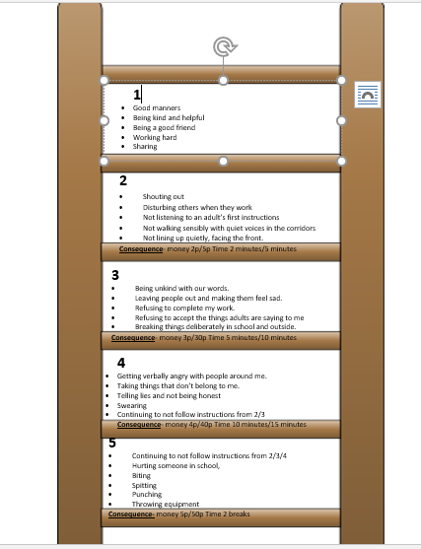

Appendix 3: Behaviour expectations at The Grove Primary School

